Q1. Caesar Cipher with Cryptanalysis
# Caesar Cipher with Cryptanalysis

def encrypt(text, shift):
result = ""
for ch in text:
if ch.isalpha():
if ch.isupper():
result += chr((ord(ch) - ord('A') + shift) % 26 + ord('A'))
else:
result += chr((ord(ch) - ord('a') + shift) % 26 + ord('a'))
else:
result += ch
return result

def decrypt(text, shift):
return encrypt(text, -shift)

text = input("Enter Plain Text: ")
shift = int(input("Enter Shift Value: "))

cipher = encrypt(text, shift)
print("Encrypted Text:", cipher)

plain = decrypt(cipher, shift)
print("Decrypted Text:", plain)

print("\nCryptanalysis (All Possible Shifts):")
for s in range(26):
print("Shift", s, ":", decrypt(cipher, s))

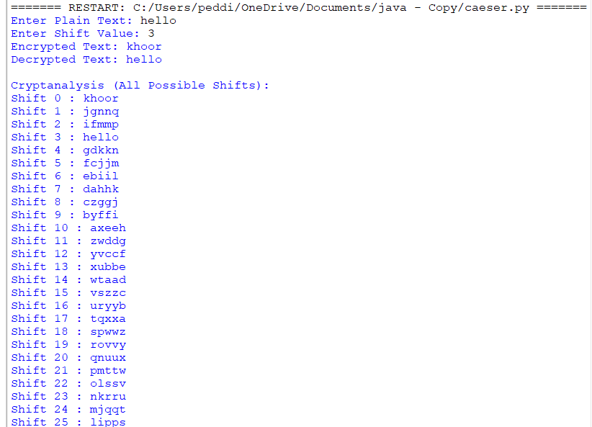
Q2:Monoalpahbetic:

def encrypt(text, shift):
result = ""

for ch in text:
if ch.isalpha():
if ch.isupper():
result += chr((ord(ch) - ord('A') + shift) % 26 + ord('A'))
else:
result += chr((ord(ch) - ord('a') + shift) % 26 + ord('a'))
else:
result += ch

return result

def decrypt(text, shift):
return encrypt(text, -shift)

# Input
text = input("Enter Plain Text: ")
shift = int(input("Enter Shift Value: "))

# Encryption
cipher = encrypt(text, shift)
print("Encrypted Text:", cipher)

# Decryption
plain = decrypt(cipher, shift)
print("Decrypted Text:", plain)

# Cryptanalysis
print("\nCryptanalysis (All Possible Shifts):")
for s in range(26):
print("Shift", s, ":", decrypt(cipher, s))

def encrypt(text, shift):
result = ""

for ch in text:
if ch.isalpha():
if ch.isupper():
result += chr((ord(ch) - ord('A') + shift) % 26 + ord('A'))
else:
result += chr((ord(ch) - ord('a') + shift) % 26 + ord('a'))
else:
result += ch

return result

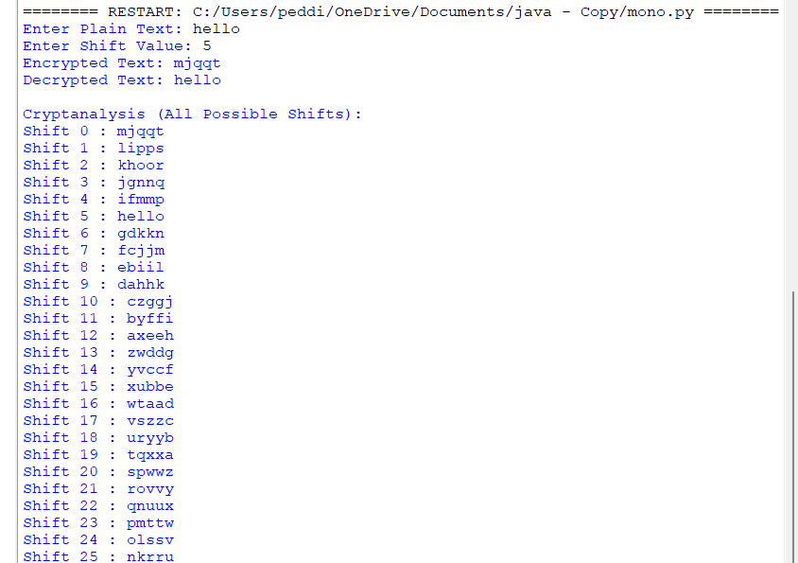

Q3:vigenere cipher
Code:
# Function to encrypt
def encrypt(plaintext, keyword):
ciphertext = ""
keyword = keyword.upper()
k = 0

for ch in plaintext.upper():
if ch.isalpha():
p = ord(ch) - ord('A')
key = ord(keyword[k % len(keyword)]) - ord('A')
c = (p + key) % 26
ciphertext += chr(c + ord('A'))
k += 1
else:
ciphertext += ch

return ciphertext

# Function to decrypt
def decrypt(ciphertext, keyword):
plaintext = ""
keyword = keyword.upper()
k = 0

for ch in ciphertext.upper():
if ch.isalpha():
c = ord(ch) - ord('A')
key = ord(keyword[k % len(keyword)]) - ord('A')
p = (c - key) % 26
plaintext += chr(p + ord('A'))
k += 1
else:
plaintext += ch

return plaintext

# Basic Kasiski Analysis
def kasiski(ciphertext):
print("\nRepeated 3-letter Sequences:")

found = False

for i in range(len(ciphertext) - 2):
seq = ciphertext[i:i+3]

for j in range(i + 3, len(ciphertext) - 2):
if seq == ciphertext[j:j+3]:
print(seq, "found at positions", i, "and", j)
print("Distance:", j - i)
found = True

if not found:
print("No repeated sequences found.")

# Main Program
plaintext = input("Enter Plaintext: ")
keyword = input("Enter Keyword: ")

ciphertext = encrypt(plaintext, keyword)
print("\nEncrypted Text:", ciphertext)

decrypted = decrypt(ciphertext, keyword)
print("Decrypted Text:", decrypted)

kasiski(ciphertext)

print("\nEstimated Key Length:")
print("Check the common factors of the distances above.")

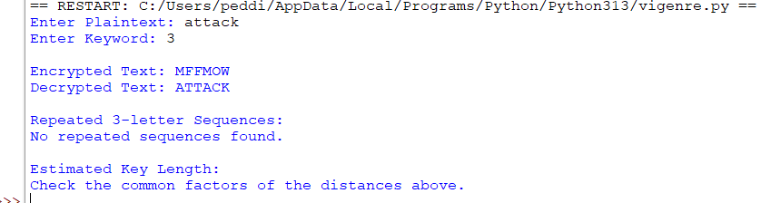

Q4:hill cipher

# Function to find modular inverse
def mod_inverse(a, m):
a = a % m
for x in range(1, m):
if (a * x) % m == 1:
return x
return None

# Encrypt function
def encrypt(text, key):
text = text.upper().replace(" ", "")

if len(text) % 2 != 0:
text += "X"

cipher = ""

for i in range(0, len(text), 2):
p1 = ord(text[i]) - 65
p2 = ord(text[i + 1]) - 65

c1 = (key[0][0] * p1 + key[0][1] * p2) % 26
c2 = (key[1][0] * p1 + key[1][1] * p2) % 26

cipher += chr(c1 + 65)
cipher += chr(c2 + 65)

return cipher

# Decrypt function
def decrypt(cipher, inv_key):
plain = ""

for i in range(0, len(cipher), 2):
c1 = ord(cipher[i]) - 65
c2 = ord(cipher[i + 1]) - 65

p1 = (inv_key[0][0] * c1 + inv_key[0][1] * c2) % 26
p2 = (inv_key[1][0] * c1 + inv_key[1][1] * c2) % 26

plain += chr(p1 + 65)
plain += chr(p2 + 65)

return plain

# Main Program
print("Enter 2x2 Key Matrix:")

a = int(input())
b = int(input())
c = int(input())
d = int(input())

key = [[a, b], [c, d]]

# Determinant
det = (a * d - b * c) % 26

inv_det = mod_inverse(det, 26)

if inv_det is None:
print("Invalid Key Matrix")
else:
print("Valid Key Matrix")

# Adjoint Matrix
inv_key = [
[( d * inv_det) % 26, (-b * inv_det) % 26],
[(-c * inv_det) % 26, ( a * inv_det) % 26]
]

plaintext = input("Enter Plaintext: ")

ciphertext = encrypt(plaintext, key)
print("Encrypted Text:", ciphertext)

decrypted = decrypt(ciphertext, inv_key)
print("Decrypted Text:", decrypted)

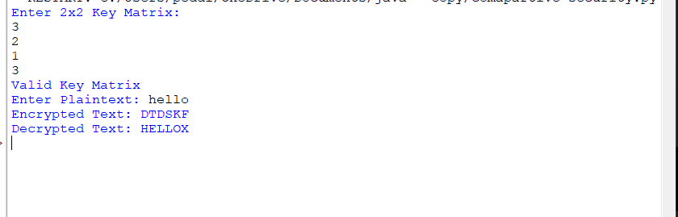
Q5: Comparative cipher
import random
import time

# ---------------- Caesar Cipher ----------------
def caesar(text, key):
result = ""
for ch in text.upper():
if ch.isalpha():
result += chr((ord(ch)-65+key)%26+65)
else:
result += ch
return result

# ---------------- Monoalphabetic Cipher ----------------
alphabet = "ABCDEFGHIJKLMNOPQRSTUVWXYZ"
letters = list(alphabet)
random.shuffle(letters)
sub_key = "".join(letters)

def mono(text):
result = ""
for ch in text.upper():
if ch.isalpha():
result += sub_key[alphabet.index(ch)]
else:
result += ch
return result

# ---------------- Vigenere Cipher ----------------
def vigenere(text, keyword):
result = ""
k = 0
keyword = keyword.upper()

for ch in text.upper():
if ch.isalpha():
p = ord(ch)-65
key = ord(keyword[k % len(keyword)])-65
result += chr((p+key)%26+65)
k += 1
else:
result += ch
return result

# ---------------- Hill Cipher ----------------
key = [[3,3],[2,5]]

def hill(text):
text = text.upper().replace(" ","")

if len(text)%2!=0:
text += "X"

result = ""

for i in range(0,len(text),2):
p1 = ord(text[i])-65
p2 = ord(text[i+1])-65

c1 = (key[0][0]*p1 + key[0][1]*p2)%26
c2 = (key[1][0]*p1 + key[1][1]*p2)%26

result += chr(c1+65)
result += chr(c2+65)

return result

# ---------------- Frequency Count ----------------
def frequency(text):
freq = {}
for ch in text:
if ch.isalpha():
freq[ch] = freq.get(ch,0)+1
return freq

# ---------------- Main ----------------
plaintext = input("Enter Plaintext: ")
keyword = input("Enter Vigenere Keyword: ")

# Caesar
start = time.time()
c1 = caesar(plaintext,3)
t1 = time.time()-start

# Monoalphabetic
start = time.time()
c2 = mono(plaintext)
t2 = time.time()-start

# Vigenere
start = time.time()
c3 = vigenere(plaintext,keyword)
t3 = time.time()-start

# Hill
start = time.time()
c4 = hill(plaintext)
t4 = time.time()-start

print("\n---------------- Comparative Analysis ----------------")

print("{:<18}{:<20}{:<20}".format("Cipher","Ciphertext","Execution Time"))
print("-"*60)

print("{:<18}{:<20}{:<20.8f}".format("Caesar",c1,t1))
print("{:<18}{:<20}{:<20.8f}".format("Monoalphabetic",c2,t2))
print("{:<18}{:<20}{:<20.8f}".format("Vigenere",c3,t3))
print("{:<18}{:<20}{:<20.8f}".format("Hill",c4,t4))

print("\nFrequency Distribution")

print("\nCaesar :",frequency(c1))
print("Mono :",frequency(c2))
print("Vigenere:",frequency(c3))
print("Hill :",frequency(c4))
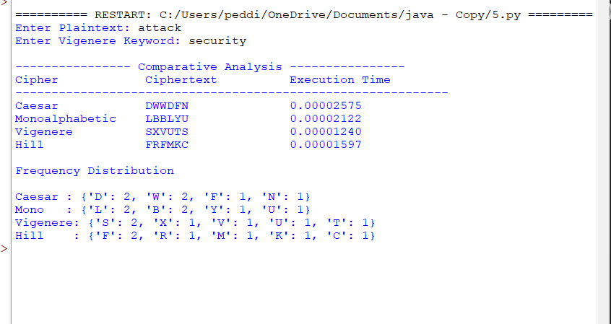b

